**RIPHAH INTERNATIONAL UNIVERSITY ISLAMABAD**



**Lab #12**

**Subject: Operating system**

**Submitted to: MS. Kausar**

**Submitted by: Noor ul huda**

**Sap ID: 46053**

**Q1: Which command would you use to find the process ID (PID) of a process named OSLab without running it. After obtaining the PID, which command would you use to kill the process?**

• **Finding the PID of a Process:**

To find the process ID (PID) of a running process named OSLab, you can use the

pgrep command:

**pgrep OSLab**

This command will return the PID(s) of any running process with the name OSLab.

• **Killing the Process:**

Once you have the PID, you can use the kill command to terminate the process. For example, if the PID is 1234, you would run:

**kill 1234**

Alternatively, if you want to kill all instances of OSLab, you can combine the pgrep and kill commands like this:

**pkill OSLab**

**Q2: How would you write a script that uses a signal trap to handle specific signals, and what is the purpose of a signal trap in such a script?**

A signal trap allows a script to "catch" specific signals and handle them in a custom way, rather than immediately terminating or taking default action. Signal traps are often used for cleanup tasks or graceful shutdowns.

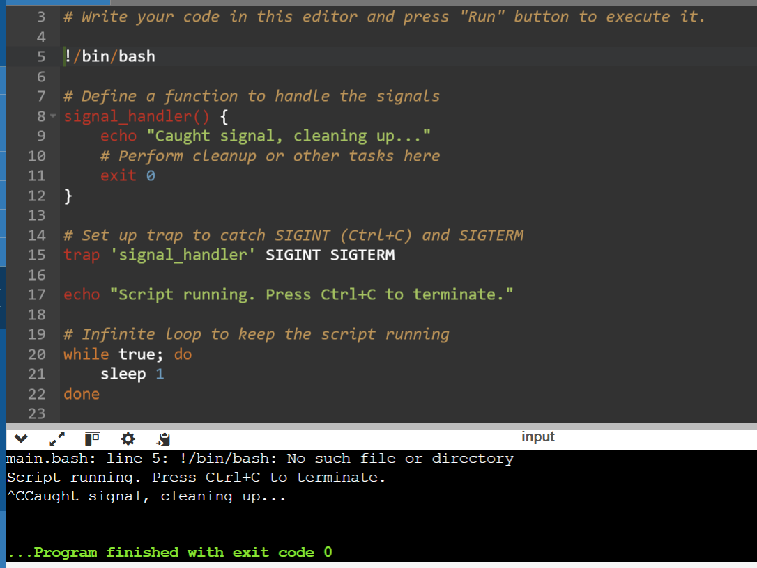

* **Purpose of the Signal Trap:** A signal trap intercepts specified signals (like SIGINT or SIGTERM) and runs a custom handler function instead of terminating the script immediately. This is useful when you need to perform cleanup operations, such as closing files, freeing resources, or printing a message before exiting.
* **How It Works:**
  + The trap command binds specific signals to a handler function (signal_handler in this case).
  + When the script receives SIGINT or SIGTERM, the signal_handler function is executed, allowing you to perform any necessary actions before the script exits.

This script will run indefinitely until it receives a signal, at which point it will catch and handle the signal according to the defined function.